

**COE 371L   
Lab #6 – Wireless LAN**

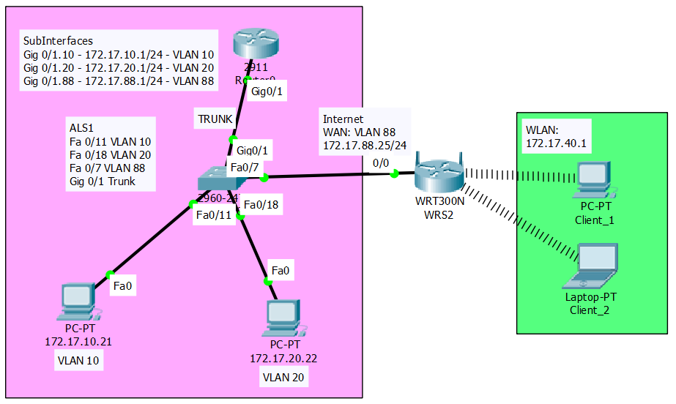

**Wireless Router 300N**

In this topology we are using the Wireless router 300N. This router has no CLI interface. You need to configure this device using the GUI dialog boxes.

**Pre-Lab Questions**

1. What is the SSID and what is it used for?
2. What is the communication medium used in WLAN?
3. What is the IEEE standard that governs WLANs?
4. List the differences between a, b, g and n WLAN standards in terms of frequency, speed and distance.
5. A ‘g’ wireless client using the can connect to an Access Point using the ‘a’ standard?[TRUE | FALSE]

**Reset Switches**

Before starting the lab, make sure you reset the switch configuration:

**# erase startup-config**

**# delete vlan.dat**

**# reload**

**Reset Routers**

Before starting the lab, make sure you reset the router configuration:

**# erase startup-config**

**# reload**

**Switch show commands**

**# show mac address-table**

**# show vlan br**

**# show interface fastethernet 0/5**

**# show ip interface brief**

**Router show commands**

**# show run**

**# show ip route**

**# show ip interface brief**

### Task 1: Load the starting configurations.

#### Step 1. Load GW’s configurations.

**!**

**hostname GW  
!**

**interface GigabitEthernet0/1.10**

**encapsulation dot1Q 10**

**ip address 172.17.10.1 255.255.255.0**

**!**

**interface GigabitEthernet0/1.20**

**encapsulation dot1Q 20**

**ip address 172.17.20.1 255.255.255.0**

**!**

**interface GigabitEthernet0/1.88**

**encapsulation dot1Q 88**

**ip address 172.17.88.1 255.255.255.0**

**!**

#### Step 2. Load S2’s configurations.

**!**

**hostname S2**

**!**

**!**

**interface FastEthernet0/7**

**switchport mode access**

**switchport access vlan 88**

**!**

**interface FastEthernet0/11**

**switchport mode access**

**switchport access vlan 10**

**!**

**interface FastEthernet0/18**

**switchport mode access**

**switchport access vlan 20**

**!**

**!**

**interface GigabitEthernet0/1**

**switchport mode trunk**

**!**

**Lab Procedure:**

1. Connect the physical topology
2. Connect switch Fa 0/7 to wireless router Internet port (0/0)
3. Configure router sub-Interfaces (Gig 0/1.10, 0/1.20, 0/1.88) on VLAN 10, 20 and 88
4. Configure switch ports on VLAN 10 (Fa 0/11), VLAN 20 (Fa 0/18), VLAN 88 (Fa 0/7) and trunk port (Gig 0/1)
5. Configure PC IP addresses and gateway
6. Test connectivity between VLAN 10 and VLAN 20. Must be successful.
7. Configure wireless router.

**Wireless Router Configuration**

The wireless router has two interfaces:

1. WAN (Internet): this is the blue colored interface in the figure below.

2. LAN (WLAN): these are the yellow colored interfaces in the figure below.

Note: the red button is the RESET button. Click on this button for 10 seconds to reset.

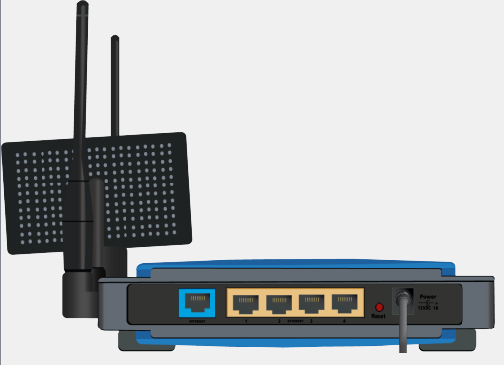

Configure the Internet WAN interface manually/statically on VLAN 88:

IP: 172.17.88.25

Mask: 255.255.255.0

Gateway: 172.17.88.1 (wireless router uses the router gi 0/1.88 sub-interface as a gateway)

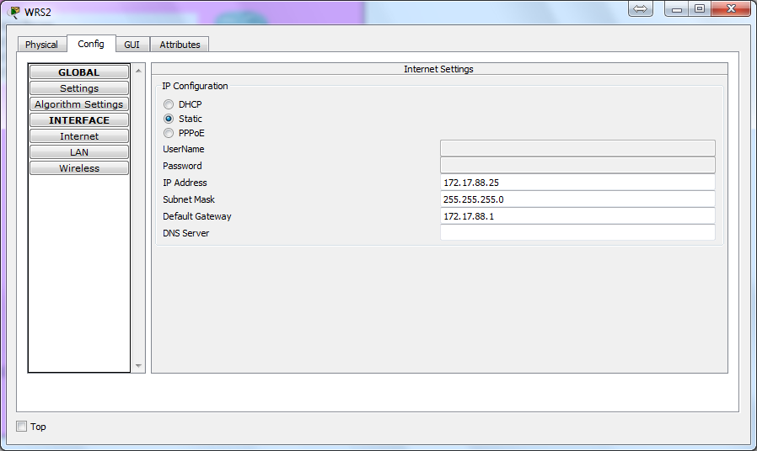

Client hosts can connect to the LAN either wired or wirelessly.

Configure the LAN (WLAN) interface on VLAN 40:

IP: 172.17.40.1

Mask: 255.255.255.0

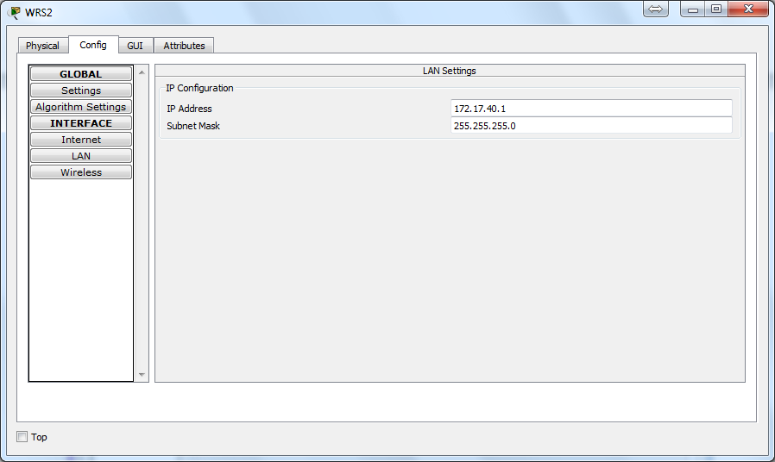

PSK stands for **P**re-**S**hared **K**ey. This is the password required to join the WiFi network.

Configure the WLAN settings:

SSID: COE_371_WLAN

Channel: 11

Authentication: WPA2-PSK (PSK passphrase is **12345678**)

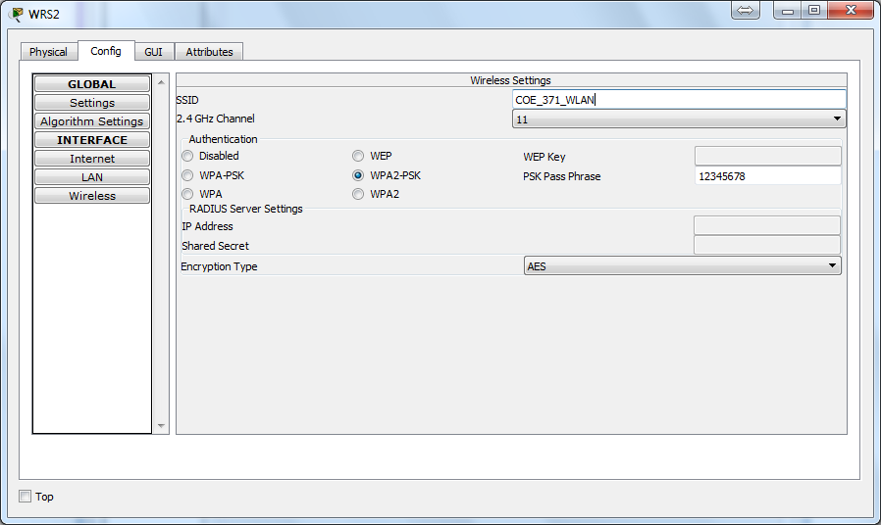

**Wireless Client Configuration**

You first need to add a **WMP 300N** wireless adaptor to the client host (PC or laptop).

To configure the wireless client, click on the **PC Wireless** icon under **Desktop** tab.

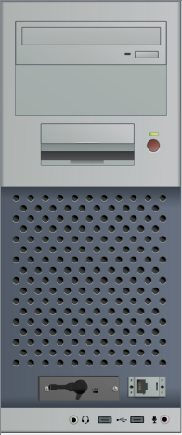

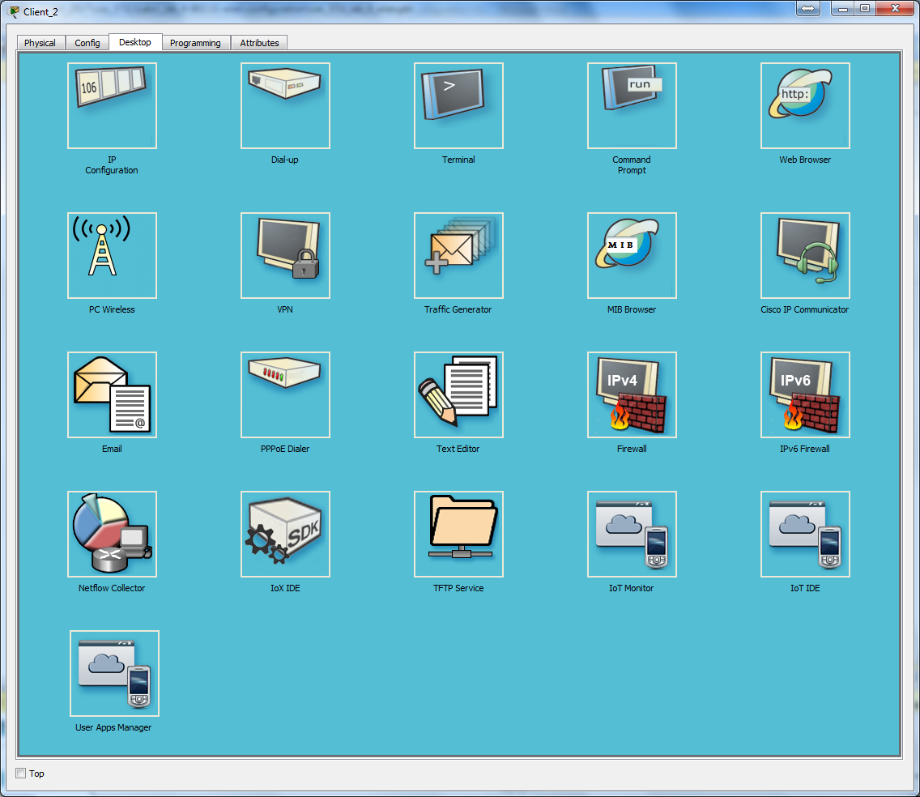

Click **Refresh** and select the WLAN **SSID** that you configured from the list then click **Connect**.

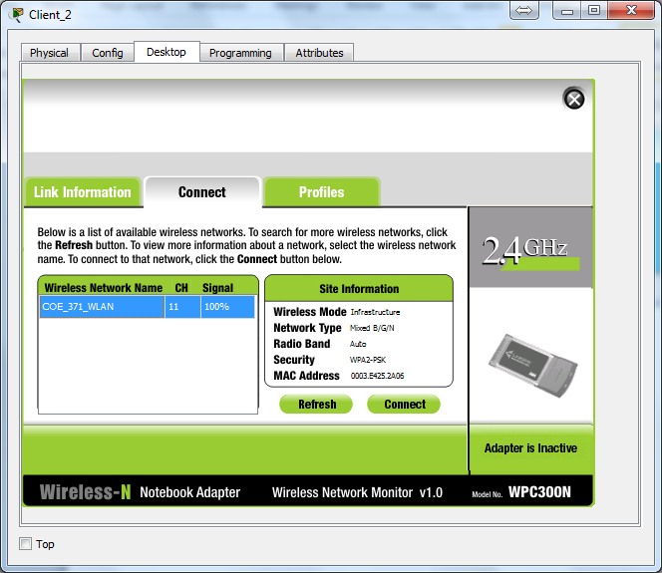

Enter the WLAN PSK password i.e. **12345678**

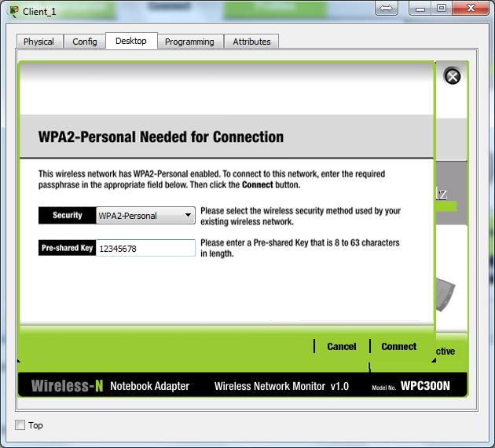

Check the wireless client IP address which should be on VLAN 40 (172.17.40.0/24) and test connectivity to remote networks (e.g. VLAN 10 or 20).

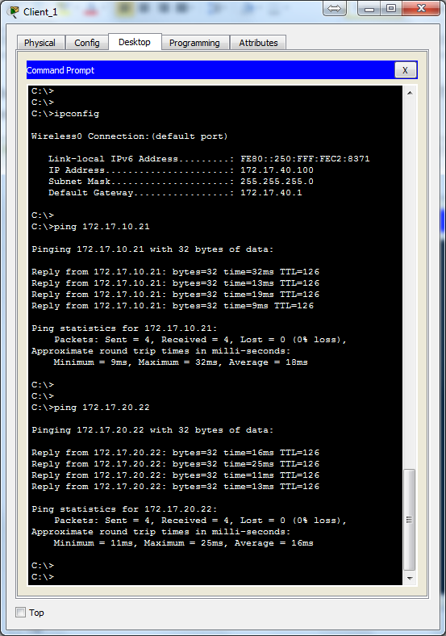

**Lab Questions**

1. A PC with one Ethernet RJ45 NIC and one wireless adapter can connect to a maximum of how many networks simultaneously?
2. Can a PC connect to more than one network simultaneously using different wireless network adapters? [YES | NO]
3. Consider a wireless router that has 5 shared keys configured. Can the wireless client use any to connect to the secured wireless network at any time? Explain.
4. 802.11a and 802.11g wireless clients can connect to an 802.11n access point? [TRUE | FALSE]
5. List three examples of authentication methods used with WLANs.
6. WEP is a stronger encryption method than WPA2. [TRUE | FALSE]
7. WPA2-Personal clients require the use of username/password to associate with the WLAN. [TRUE | FALSE]
8. Which authentication method requires the use of a RADIUS server to validate users wanting to associate with the WLAN?
9. Why is MAC address filtering considered a weak technique to secure access to a WLAN?
10. To which type of network does the Internet interface on wireless routers connect normally? [Public | Private]